Functional design documentation

for the „iCheck“ solution

for Hertz UK

|  |  |  |
| --- | --- | --- |
| **Version** | **Date** | **Author** |
| Initial draft |  | Janine Dulitz |

Content

1 Introduction & Purpose of the document 4

2 Targets & Aims of iCheck 5

3 Roles & Responsibilities 6

4 Entities of the data model 7

4.1 Car 7

4.2 Rental Agreement (RA) 7

4.3 7

4.4 CM status / Vehicle life cycle 7

5 General User Login 8

5.1 Login on mobile device 8

5.2 Chose Location 8

5.3 Main Menu task overview 9

6 Infleeting Process 11

6.1 Steps on mobile device 11

6.1.1 Capture Delivery Note Info 11

6.1.2 Capture Core Car Data (repeat x times) 12

6.1.3 Capture current Car condition (repeat x times) 13

6.1.4 Car overview (Summary of all cars with one picture plus damages) 17

6.1.5 Signature of driver 18

6.2 Steps on Server 18

6.2.1 Save data to server 18

6.2.2 Create PDF 18

6.2.3 Send Mail (+ Attachment) to driver 18

6.2.4 Create task in Worklist for activation 18

7 Defleeting process (Truck) 19

7.1 Steps on mobile device 19

7.1.1 Capture Delivery Note Info 19

7.1.2 Confirm Car condition 19

7.1.3 Car overview (Summary of all cars with one picture plus damages) 19

7.1.4 Signature of driver 19

7.2 Steps on Server 19

7.2.1 Save data to server 19

7.2.2 Create PDF 19

7.2.3 Send Mail (+ Attachment) to driver 19

7.2.4 Create task in Worklist for deactivation 19

8 Rent 20

8.1 Rent at station – Tablet at the counter 20

8.1.1 Steps on tablet 20

8.1.2 Steps on the server 20

8.1.3 Exception Handling 20

8.2 Delivery 20

9 Return 21

10 Damage handling 21

10.1 Damage Matrix definition 21

10.2 Damage capture process 21

10.3 Damage Calculation in CM3 21

11 Turnaround process 23

12 Internal / Miscellaneous movements 24

13 Maintenance 25

14 Data historization 26

15 Interface 27

15.1 Get rental agreement 27

15.2 Calculate Charges UK 27

15.3 Calculate Charges IRE 27

15.4 Commit rental agreement UK 27

15.5 Commit rental agreement IRE 27

15.6 Valid 27

# Introduction & Purpose of the document

# Targets & Aims of iCheck

# Roles & Responsibilities

|  |  |
| --- | --- |
| Role | Responsibility |
| **Country manager**  PC/Desktop | * Management of Country specific rules, lists, drop down options, … * defines hierarchy of stations and its allocation within the hierarchy (country – region – group – station) * creation of new accounts for station/group managers * assignment of roles * countrywide reporting/controlling |
| **Station supervisor/manager**  PC/Desktop | * defines all station specific rules and lists (if applicable) * creation of new accounts for CSR / service personnel * station wide reporting/analysis * owner of dashboard and worklist * delegation of his tasks to his substitute |
| **CSR** (counter)  PC/Desktop + Tablet | * matching of contract and vehicle (?) * shows current car condition incl. damages on the tablet * explains damage update * captures signature |
| **Fleet manager**  Mobile Device | * Infleeting and Defleeting process |
| **Service personnel / Field worker**  Mobile Device | * responsible to fulfil the processes defined |
| **Customer**  Mobile Device (webbased/app???) | * customer can see the current car condition (login through RA no. and last name) * customer can report new damage * customer can gather information about closest Hertz station and opening hours |

# Entities of the data model

## Car

<http://www.thecarexpert.co.uk/how-does-the-uk-number-plate-system-work/>

For data field definitions please see Excel on google drive.

## Rental Agreement (RA)

## 

For data field definitions please see Excel on google drive.

## CM status / Vehicle life cycle

* Ready for rent
* Rented
* Returned
* In Turnaround
* In Misc. Movement
* Pre-blocking warning
* In maintenance
* Ready for defleet (blocked in TAS)
* Parked

# General User Login

## Login on mobile device

Start Screen appears upon opening the iCheck app

Enter the following data:

* User ID (not case sensitive)
* Password (security standards to be defined)

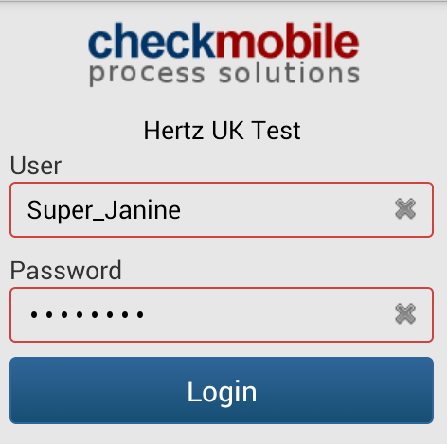

## Chose Location

When a field worker works for 1 station only, he is automatically logged in to this station.

If the fieldworker works for more than 1 station, a menu is provided to choose the current workplace from the menu.

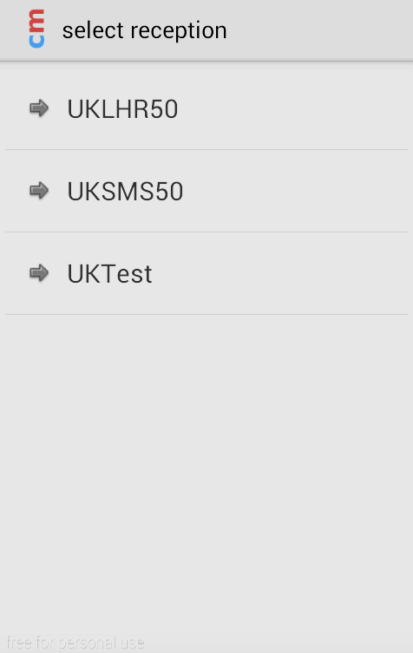

There is no validation performed to check if the worker has chosen the correct station.

When Location is chosen, the fieldworker sees an overview and can continue to main menu.

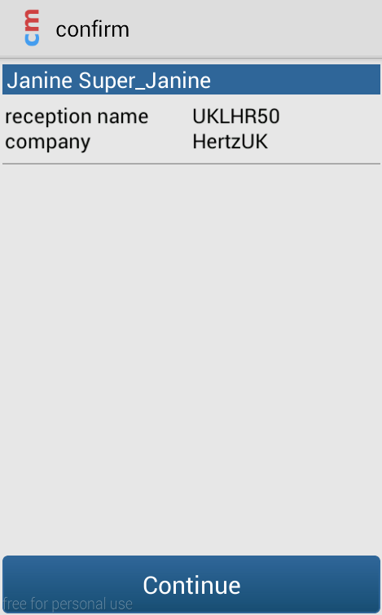

The main menu contains all tasks the fieldworker can perform

## Main Menu task overview

The main menu is the overview of all possible tasks the respective role can perform.

The following picture is an example, the tasklist will be changing throughout the project according to future tasks.

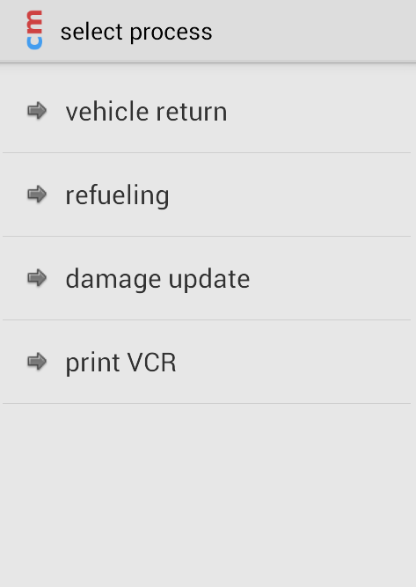

Possible additional Tasks (to be further defined):

* Vehicle Rent
* Vehicle Return (existing)
* Movements
  + Internal movements
    - Parking
    - Delivery / Return
    - Transit movement
  + Miscellaneous movements
    - Station to station
    - Infleet/Defleet
    - Bodyshop
    - Maintenance
* Turnaround
  + Cleaning
  + Refuelling
  + Debousing
* Infleeting (only for Fleet manager)
* Defleeting (only for Fleet manager)

# Infleeting Process

Open questions:

Is Infleeting of one car possible? / Would it need a separate process?

## Steps on mobile device

During infleeting process several steps have to be fulfilled to infleet a car

### Capture Delivery Note Info

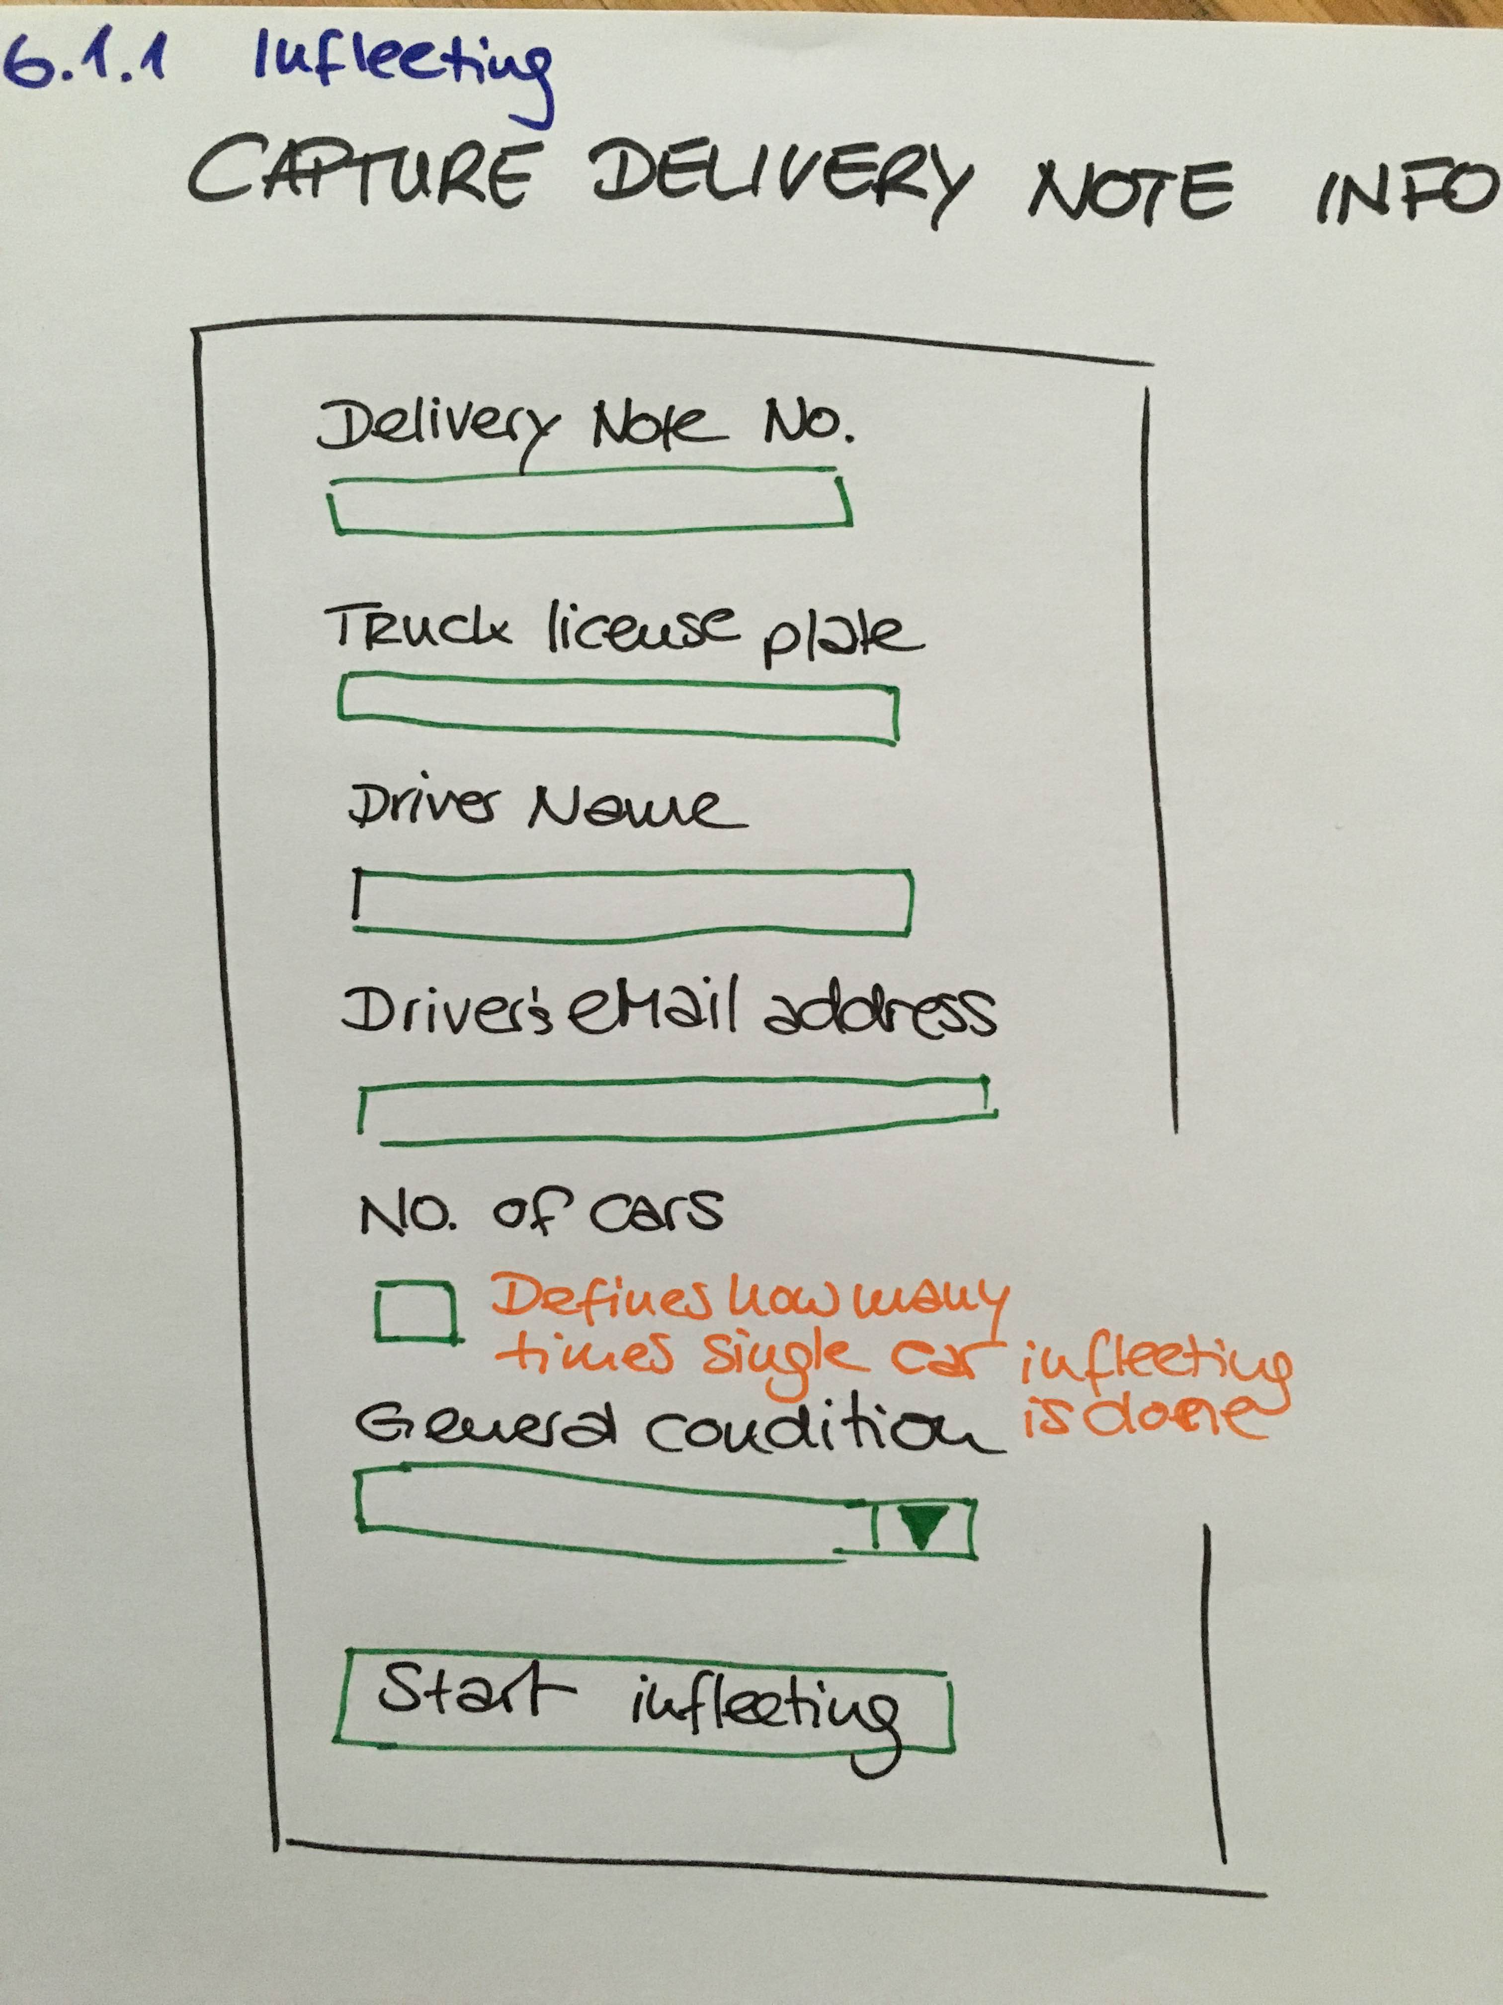

|  |  |  |  |
| --- | --- | --- | --- |
| Configuration details (attributes) | Description | Origin | Character Definition |
| Delivery Note no. | unique delivery note no. data collected and entered in TAS in a next step. Data can be collected and made available in task list to match the cars (unit no. And license plate no.) | iCheck | 10 digit varchar |
| Truck license plate |  | iCheck | according to country specific rules |
| Driver name |  | iCheck | free text |
| Driver's eMail address |  | iCheck | Free.text@freetext.Xxx |
| No. Of cars | number of cars per truck which are infleeted at the station | iCheck | 2 digit no. |
| General car condition | description of general car condition for short overview | iCheck | dropdown: dirty, full of snow, ok, |

### Capture Core Car Data (repeat x times)

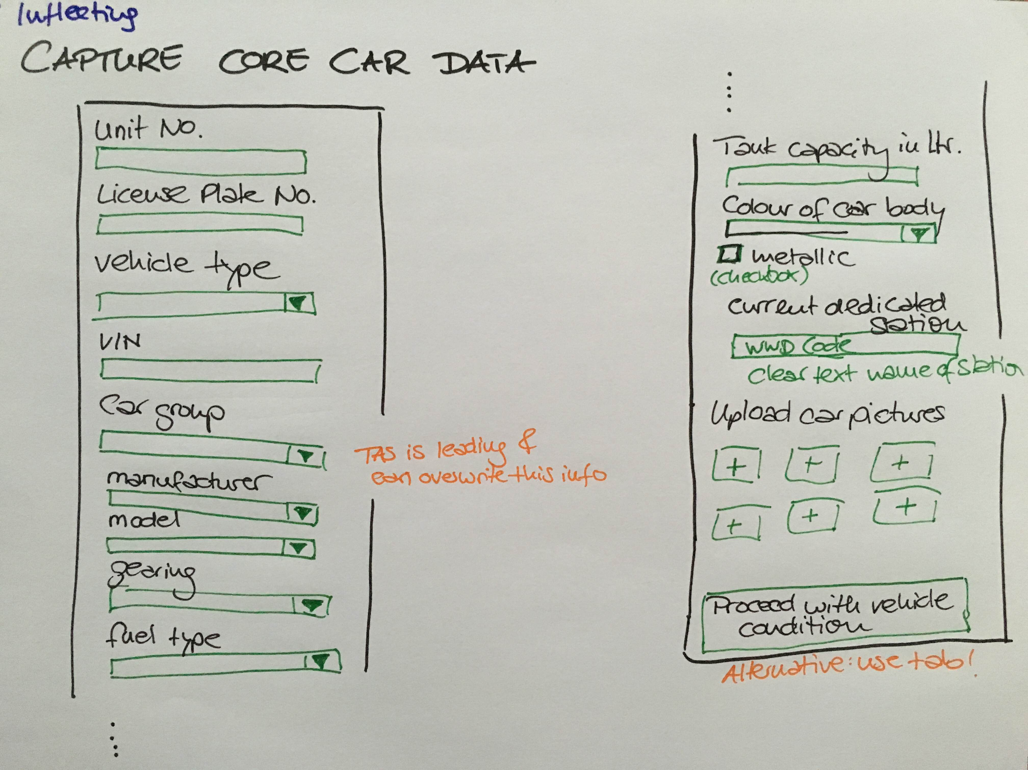

|  |  |  |  |
| --- | --- | --- | --- |
| Configuration details (attributes) | Description | Origin | Character Definition |
| unit no. | Hertz specific identification (Barcode), unique identifier | Icheck, TAS leading | 10-digit no. |
| license Plate no. | Country specific, not unique (may be reused when car was sold) | TAS leading | VARCHAR |
| VIN | unique Vehicle Identification no. | iCheck | 17 digit number |
| vehicle type | PKW/Transporter/LKW/Heavy Truck | iCheck | dropdown |
| car group | Hertz specific cagegorization of cars which lead to the rental conditions and currently (this is subject to discussion) to the corresponding prices in the damage matrix | TAS | 6-digit VARCHAR, derived data from model/car type |
| manufacturer | Predefined list of manufacturers; field to be filled during infleeting | iCheck | predefined list |
| model | car model - dropdown list; choice depending on manufacturers | iCheck | predefined list, dependencies to manufacturer |
| gearing | automatic / manual/ tiptronic | iCheck | dropdown |
| fuel type | diesel/Super/Harnstoff/Gas | iCheck | dropdown |
| tank capacity liter | size of the tank and amount of liters to be filled in for full tank | iCheck | 3 digit number |
| colour of car body | simplified colour (black, grey, silver, white, blue, green, red, yellow) | iCheck | dropdown + checkbox for "metallic" |
| current dedicated station | Station, the car currently belongs to. Station can be changed with internal movement | iCheck | station name (WWD code), character definition needs to be clarified name of station clear text |

### Capture current Car condition (repeat x times)

This task consists of several sub-tasks

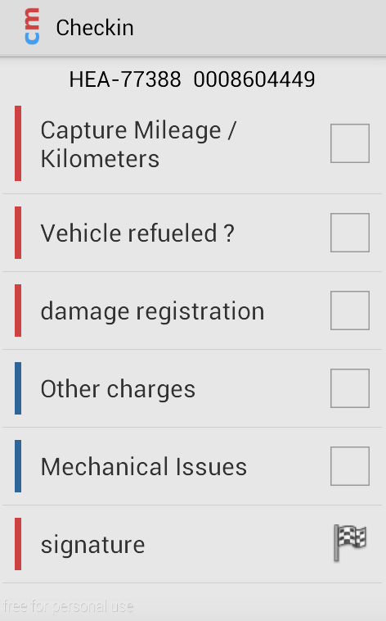

#### Capture Mileage/kilometers

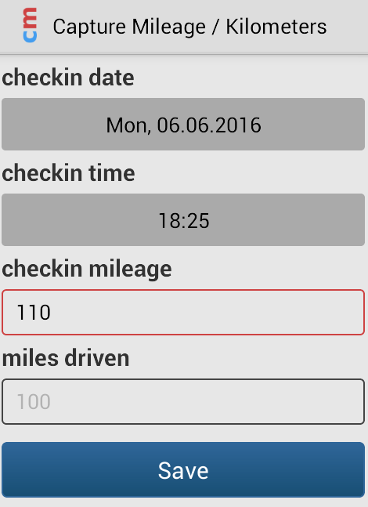

Roles apply for varification of mileage (average km/day if less: warining, if more: warning

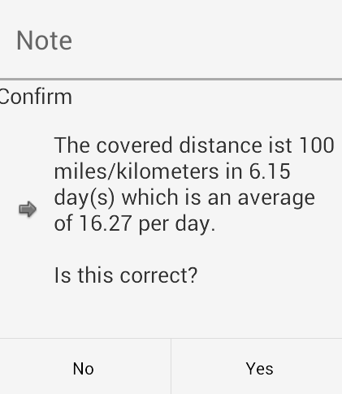

#### Vehicle Refuelled?

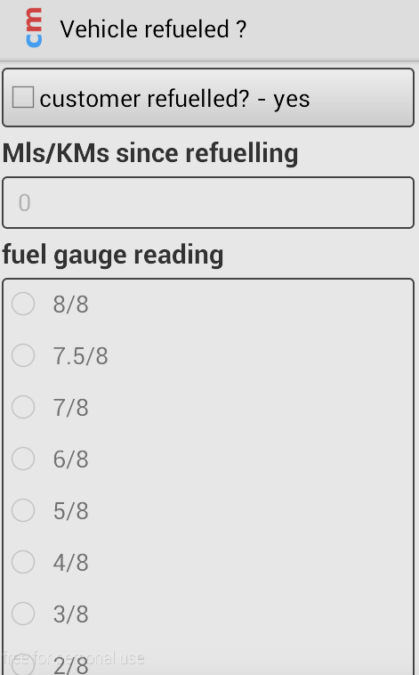

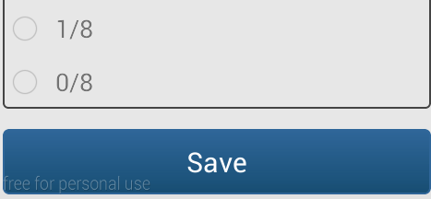

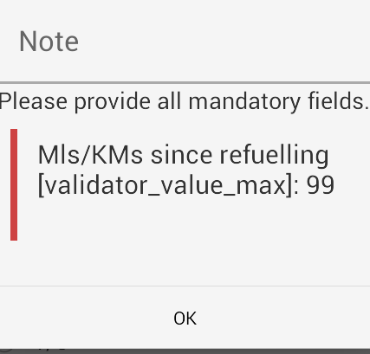

#### Damage registration

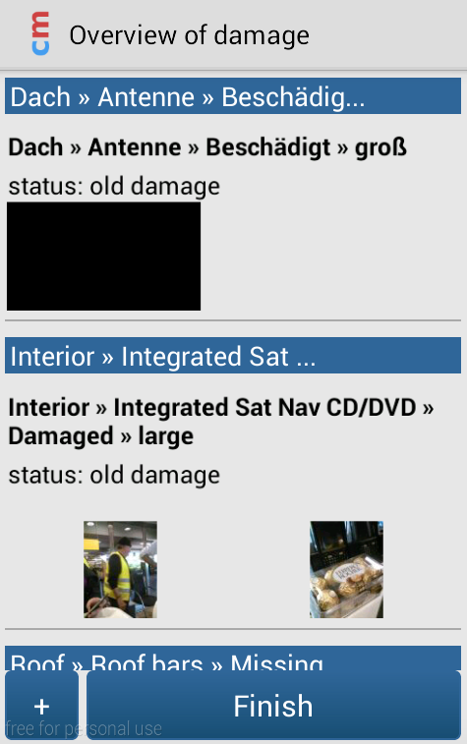

#### New Damage

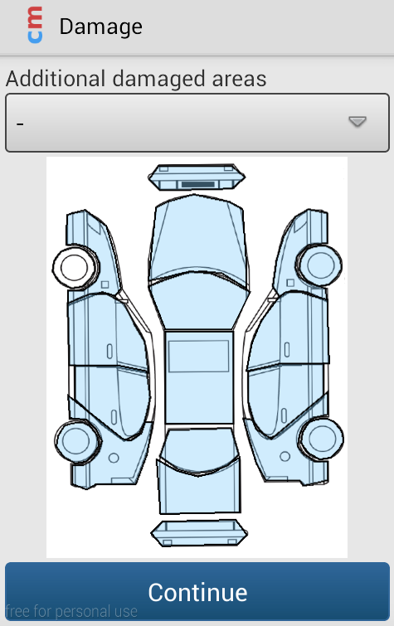

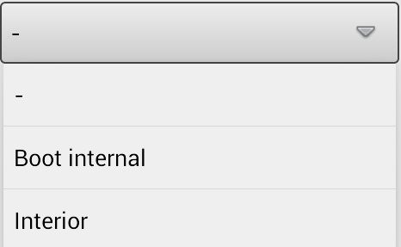

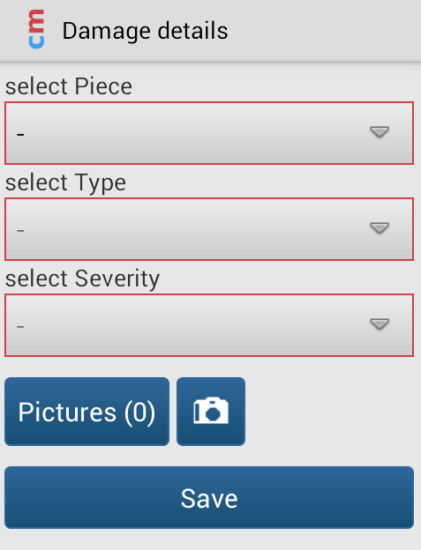

### Car overview (Summary of all cars with one picture plus damages)

The overview offers possibility to go into the details of each car again if uncertaincies occur.

The overview includes the information if damages were captured (yes/no derived data from damage capture screens).

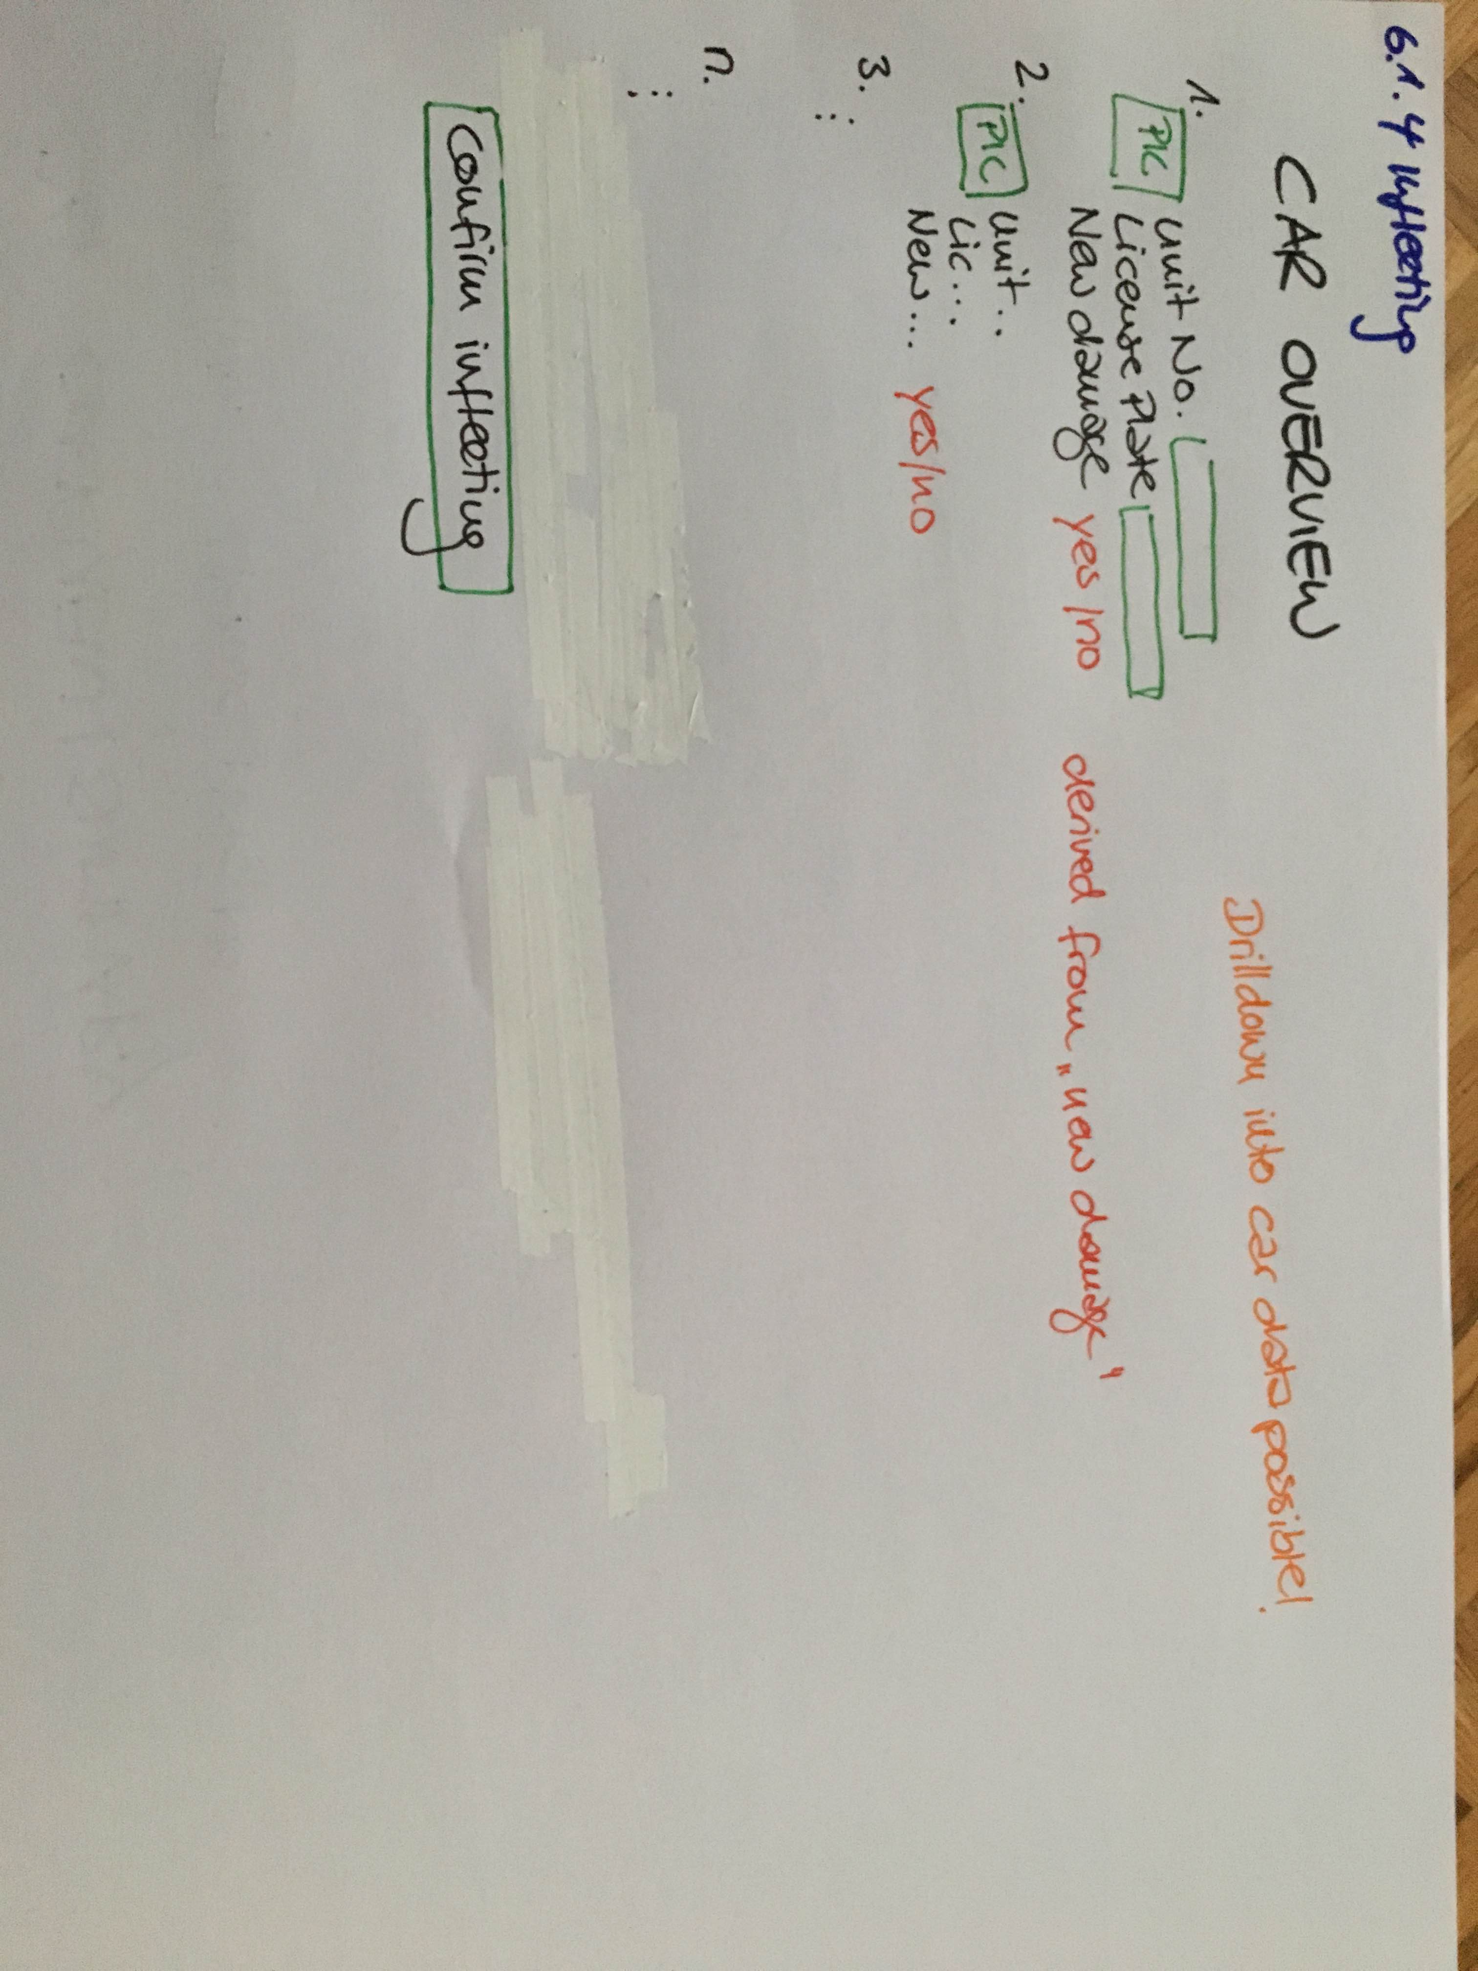

### Signature of driver

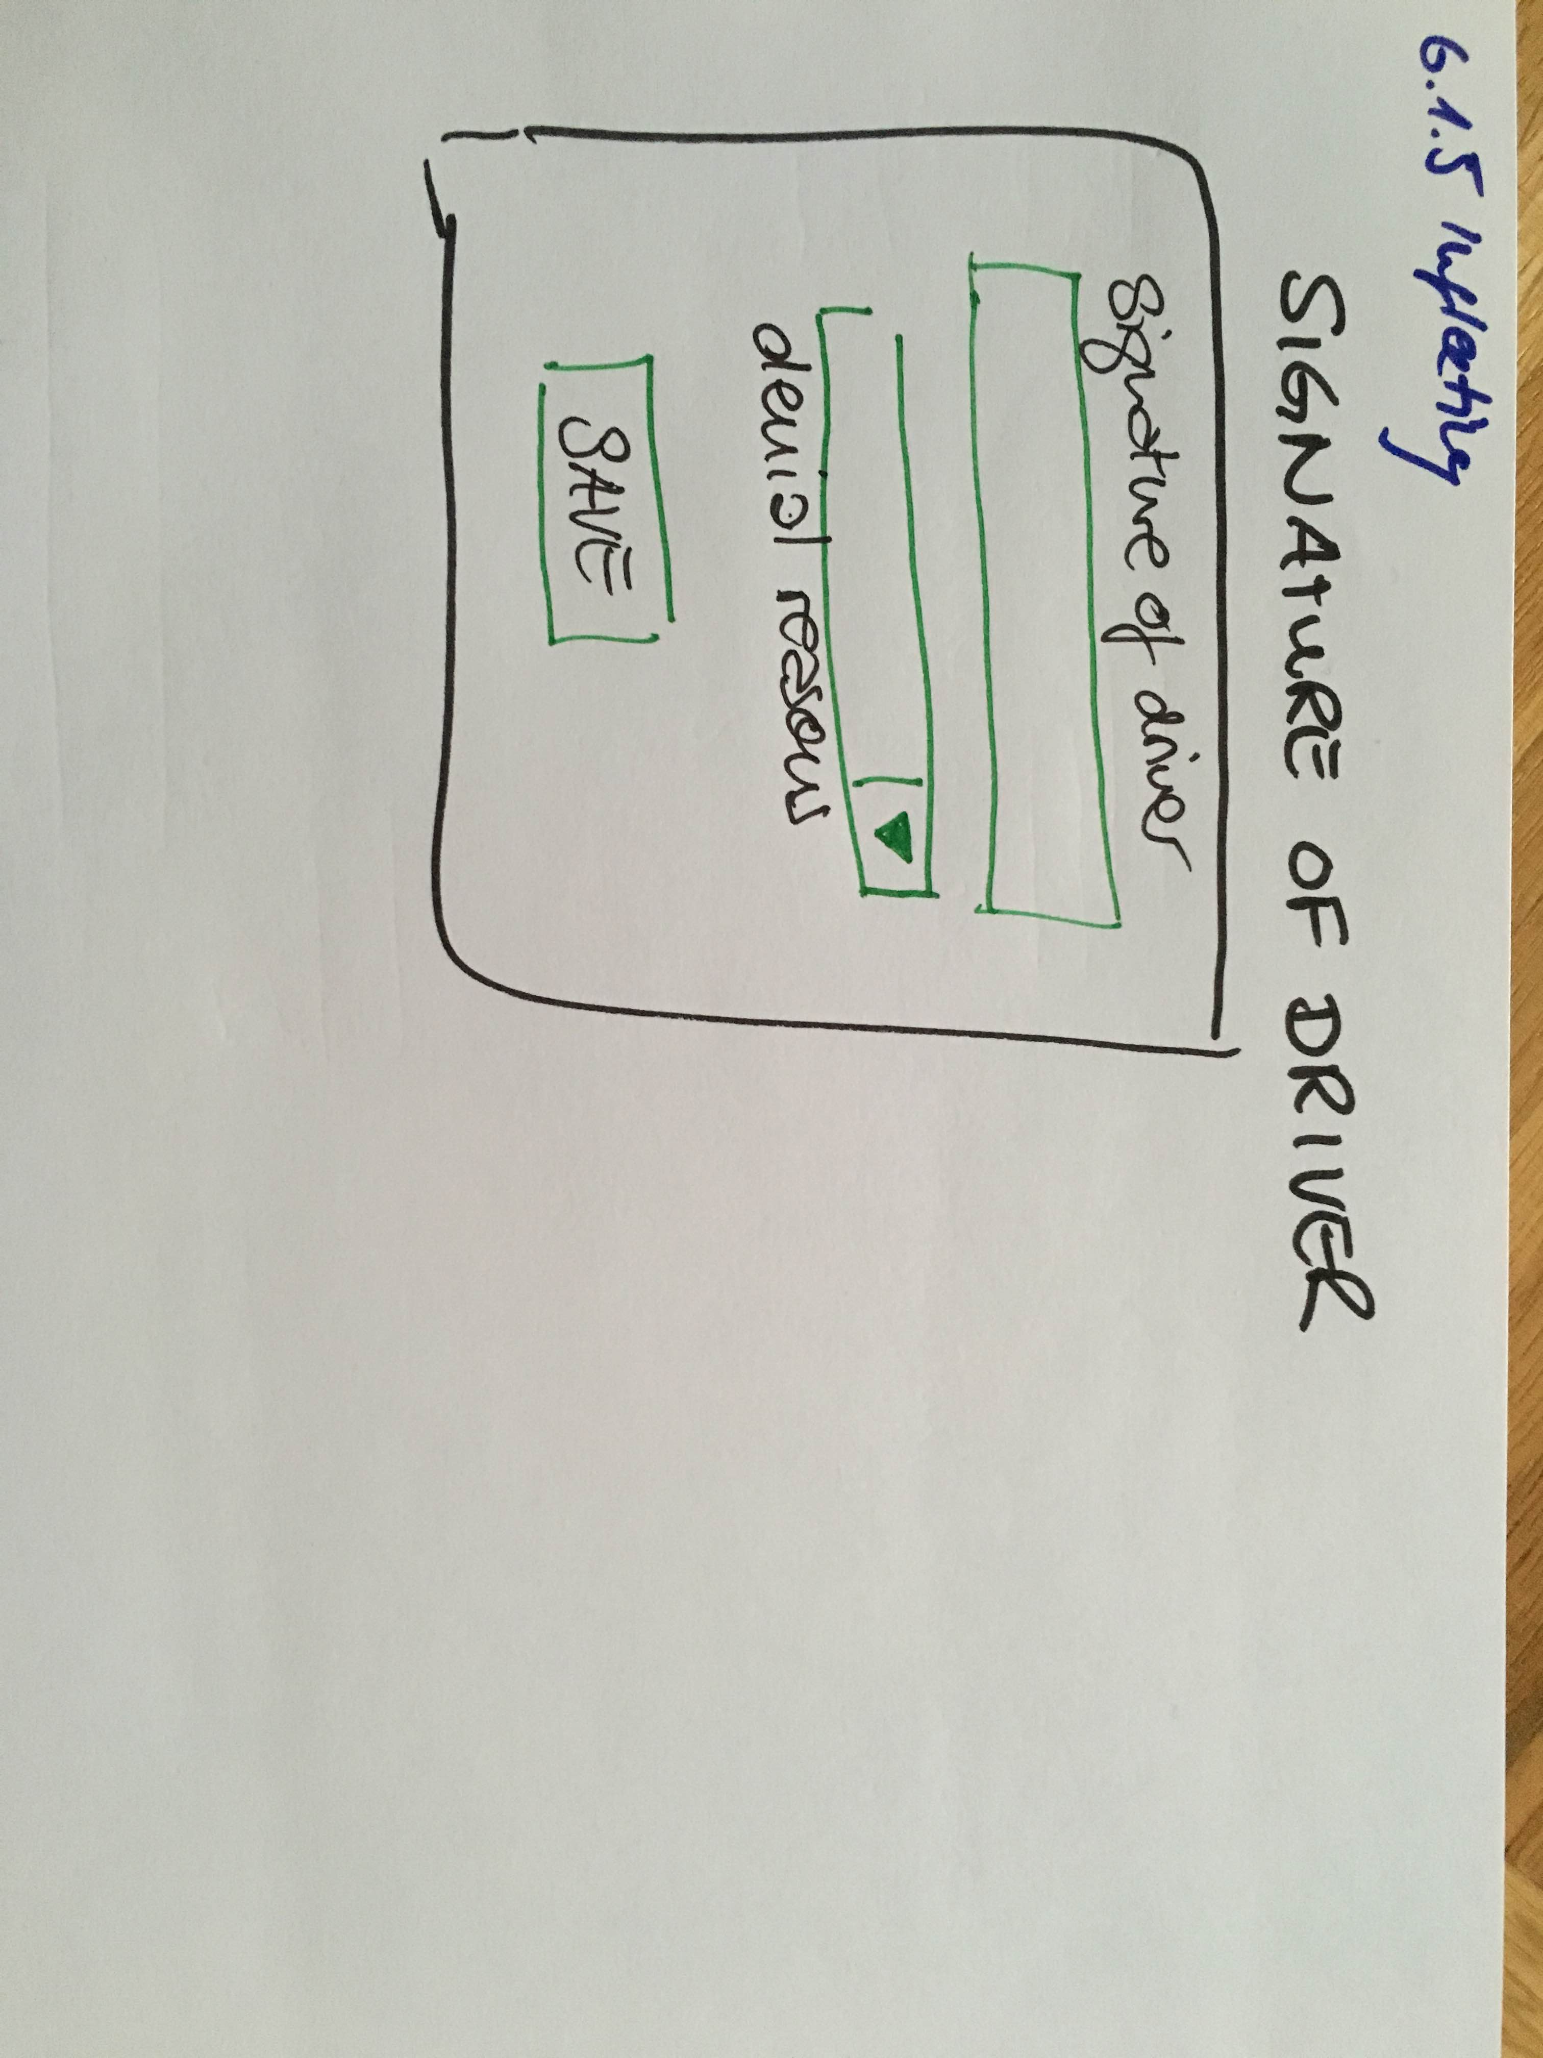

## Steps on Server

### Save data to server

### Create PDF

### Send Mail (+ Attachment) to driver

### Create task in Worklist for activation

# Defleeting process (Truck)

Is defleeting truck process different to defleeting single car?

## Steps on mobile device

### Capture Delivery Note Info

### Confirm Car condition

### Car overview (Summary of all cars with one picture plus damages)

### Signature of driver

## Steps on Server

### Save data to server

### Create PDF

### Send Mail (+ Attachment) to driver

### Create task in Worklist for deactivation

# Rent

## Rent at station – Tablet at the counter

Car is ready for rent

### Steps on tablet

#### Scan Car

#### Dispay RA overview

#### View VCR on screen (summary incl. All damages)

🡪 drilldown into details with separate page

#### Confirm 🡪 Signature + Acceptance (damage liablity) + email (not required) + print (not required)

### Steps on the server

#### Save data to CM server

#### Create PDF

#### Send email

### Exception Handling

What happens if there is a new damage on the car?

* Update damage on mobile device (customer app)
* Damage update

## Delivery

# Return

Damage handling after return (customer not present) 🡪 time window (3o mins) when FNOL is involved that damage to clarify if customer involvement?

Station Manager worklist:

* Resend data from CM Server to TAS
* Generate documents

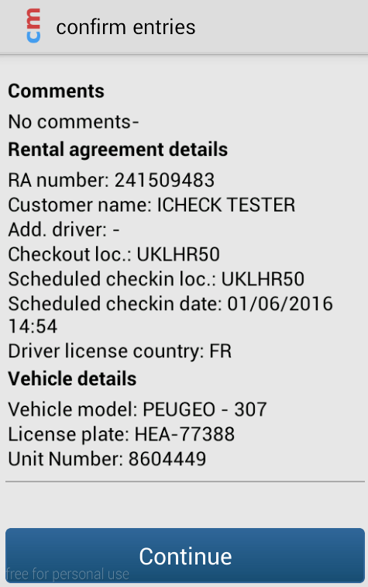

# Damage handling

## Damage Matrix definition

## Damage capture process

New damage is added to the system. For each damage a new damage has to be added. If several items are damaged, several new damages are created.

The user clicks through the damage matrix for exact location of the damaged part of the car.

The number of pictures is defined (min.2, individual definition per country and per damaged piece). Free text field with short description is provided.

## Damage Calculation in CM3

See Jira HERTZ-18 <https://checkmobile.atlassian.net/browse/HRZ-18>

# Turnaround process

# Internal / Miscellaneous movements

# Maintenance

# Data historization

Historization of transactional data (Rental agreement) – after 1 week longer access time ok

Historization of core data – full set of details

Historization/storage of pictures for the damage/car overview

# Interface

There are 4 basic web services to TAS.

## Get rental agreement

Authentification for TAS get rental contract thorugh „personal number“ – field required mandatory

## Calculate Charges UK

## Calculate Charges IRE

## Commit rental agreement UK

## Commit rental agreement IRE

## Valid

y/n